# **Neural Network Training**

## **TensorFlow implementation**

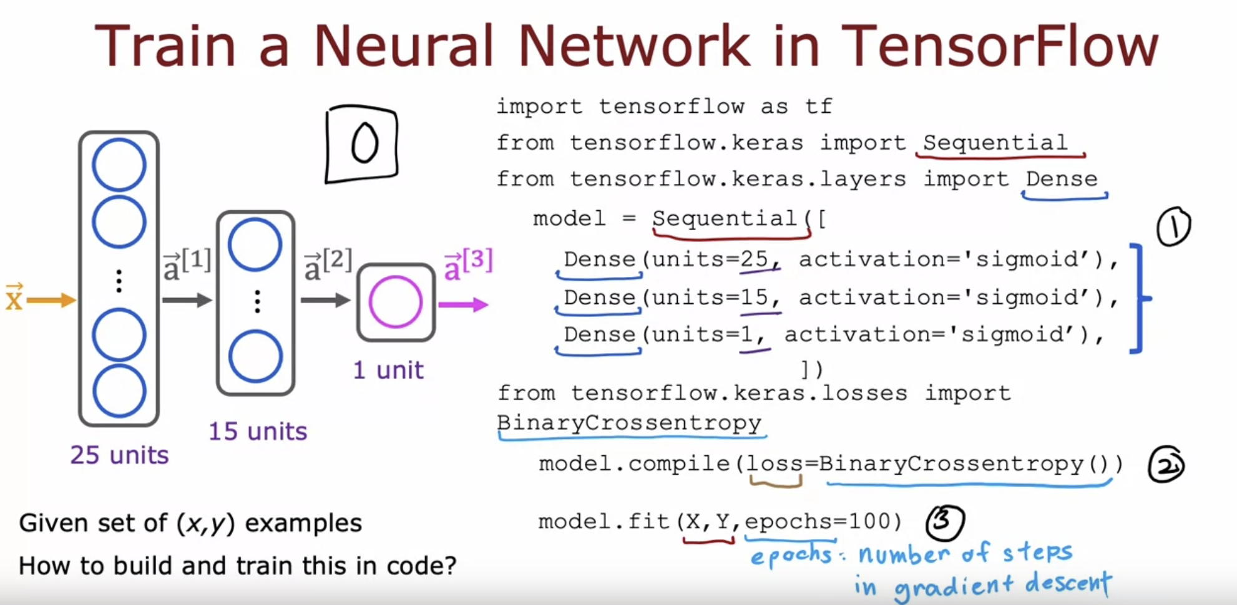

## **Training Details**

Average Loss over entire training example

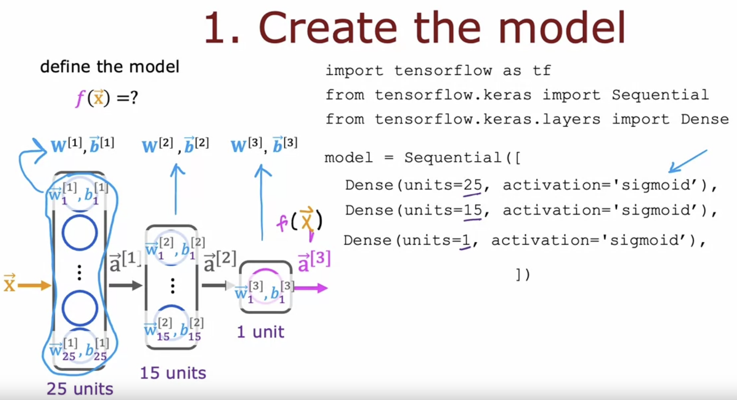

Optimizing this cost function will result in fitting the neural network to your   
binary classification data.

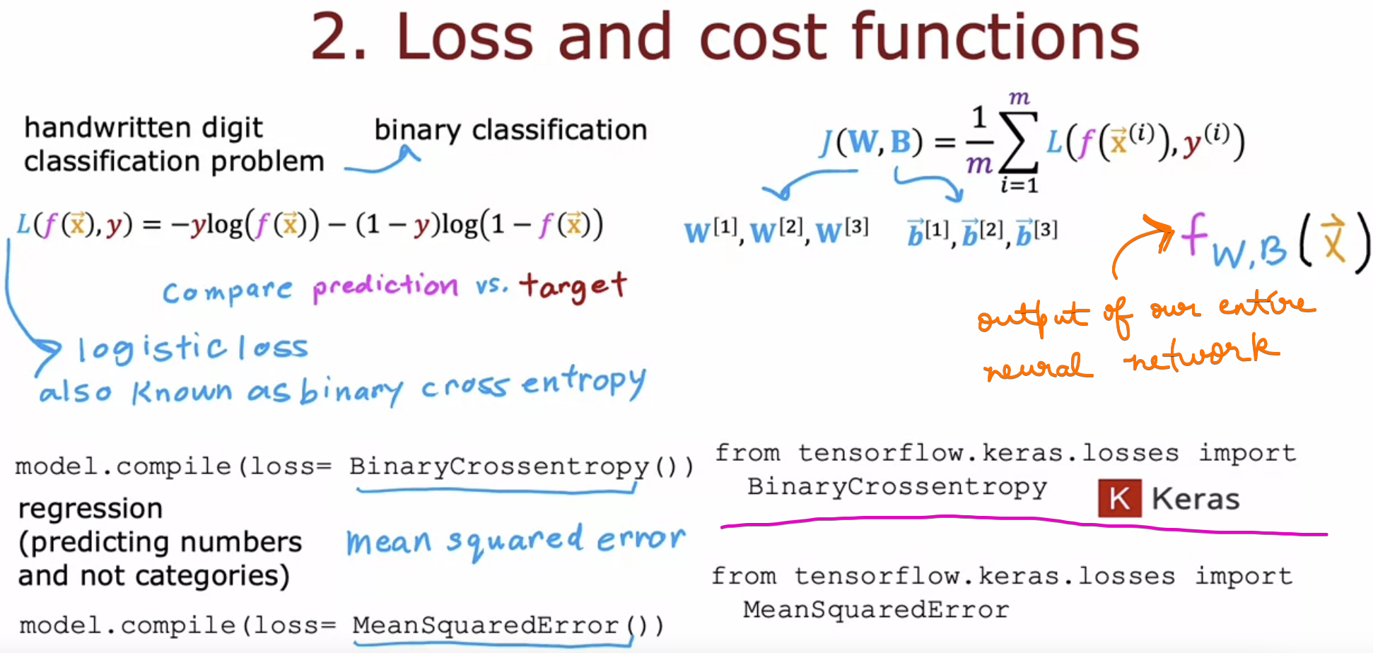

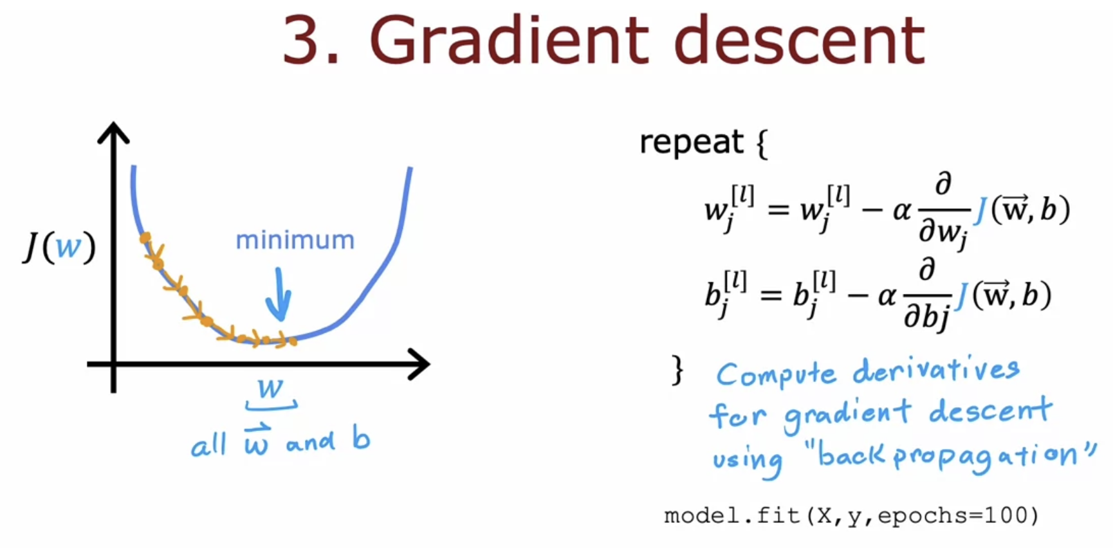

# **Quiz**

